**EDA INSIGHTS- DEHIRE**

The shape of the dataset for allot is (60174,48)

**First moment business decision**

1st Business Moment : Measures of Central Tendency -> Mean, Median, Mode

MEAN

U_Frt 1.537790

QUANTITY -1.222836

RATE 2.026928

Loading/Unloading 2.708249

Detention 4.476131

MEDIAN

U_Frt 6.0

QUANTITY -96.0

RATE 2060.0

Loading/Unloading 0.0

Detention 0.0

**Second moment business decision**

Measures of Dispersion -> Variance, Standard Deviation, Range

Standard deviation

U_Frt 3839.642345

QUANTITY 104.777690

RATE 273.672588

Loading/Unloading 158.128697

Detention 16.680644

Variance

U_Frt 1.474285

QUANTITY 1.097836

RATE 7.489669

Loading/Unloading 2.500468

Detention 2.782439

Third moment business decision-Skewness

U_Frt 5.665835

QUANTITY -0.855587

RATE -0.463772

Loading/Unloading 11.644932

Detention 46.691635

Fourth moment business decision-Kurtosis

U_Frt 53.157111

QUANTITY -0.118094

RATE 21.261927

Loading/Unloading 248.325315

Detention 2424.847169

**DOCNUM column:**

* **33467** unique purchase documents are available.

**Posting Date, create Date and Effective Date columns:**

* These columns are type casted from string to date and time.

**Customer/Vendor Code:**

* **1956** unique customers code are there which represent id of each customer.

**Customer/Vendor Name:**

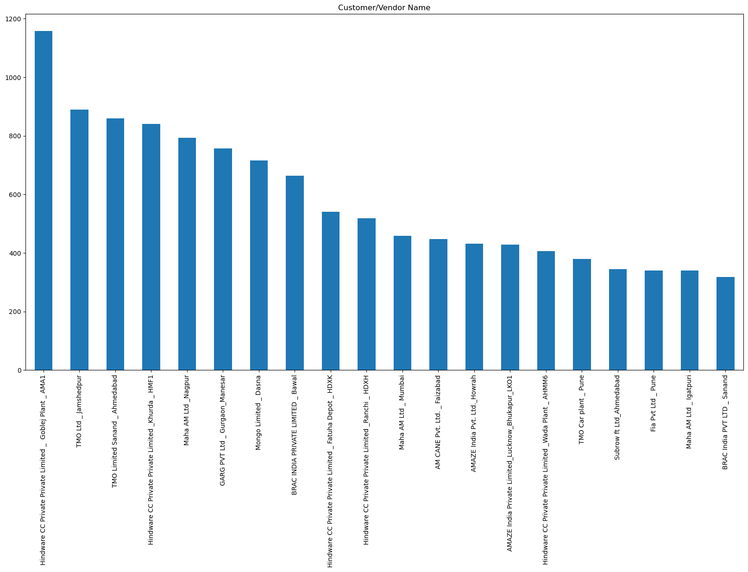

* 1956 unique customer are there
* These are the top 20 customers

**LOB column:**

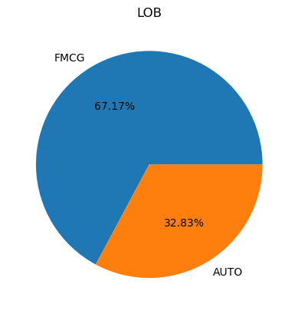

* Two unique LOBs are there AUTO and FMCG.
* AUTO 32.83% and FMCG 67.17%.

**Region column:**

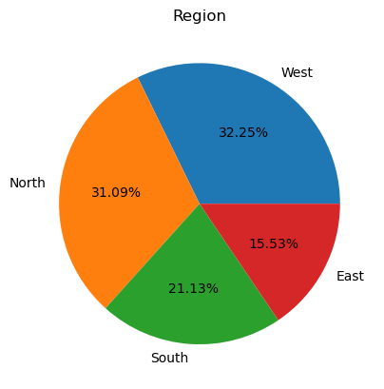

* Four regions
* West and south are mostly followed than North and East.

**BP TYPE column:**

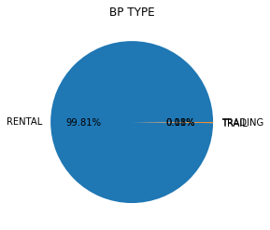

* Rental is the majority and trail done very rarely.

**City column:**

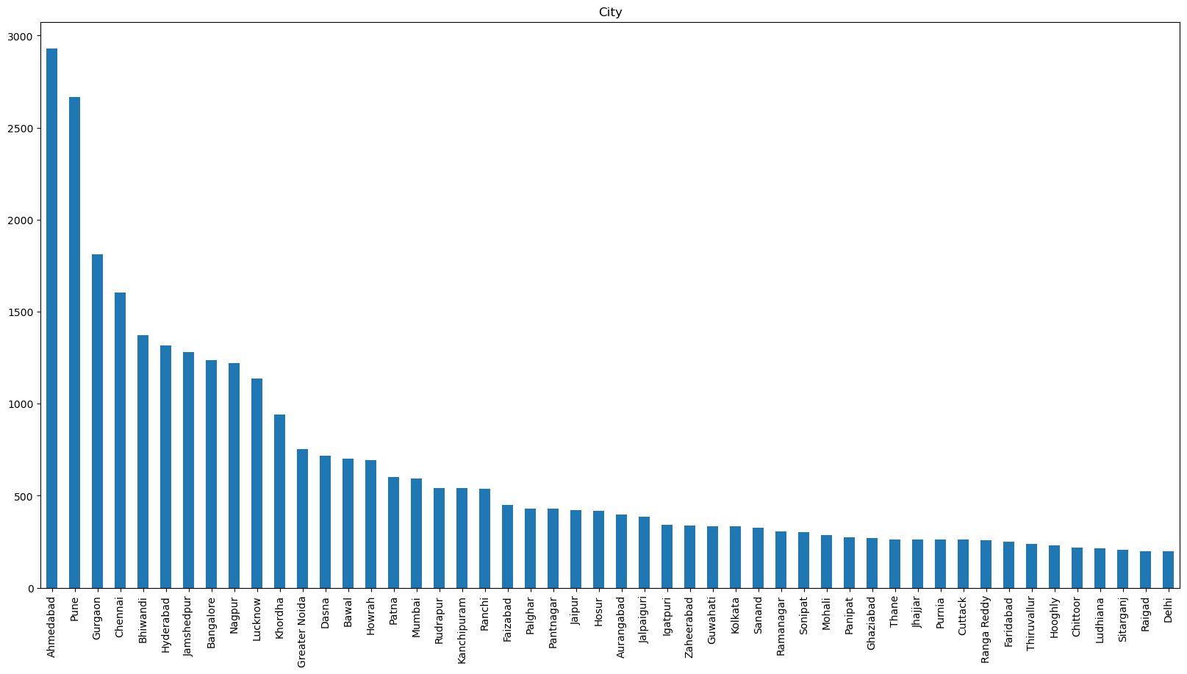

* 330 cities are there.
* These are the top 50 cities.

**State column:**

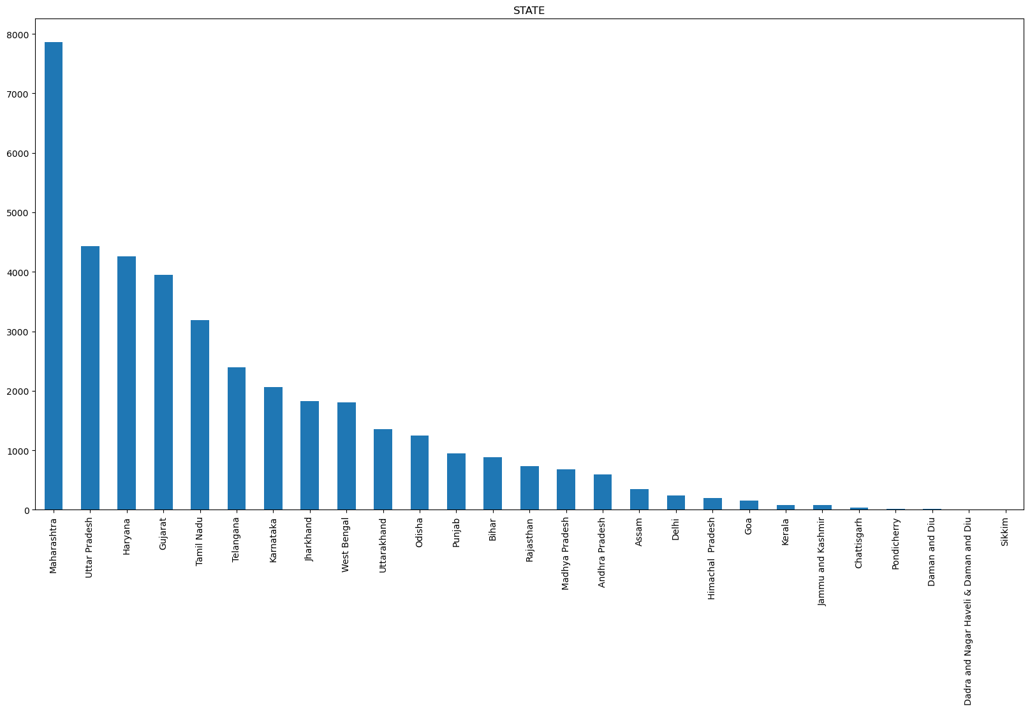

* 28 states are there

**from whs Name column:**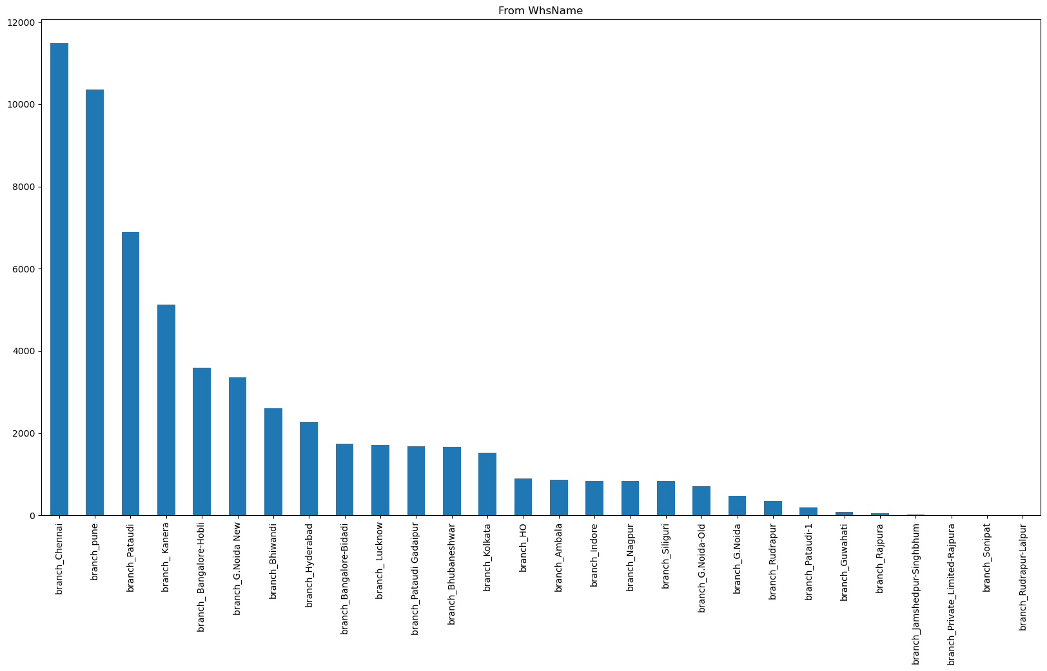

* 1939 from warehouses are there.

**from whs code column:**

* 48 unqiue from warehouses codes are there.

**To whs Name column:**

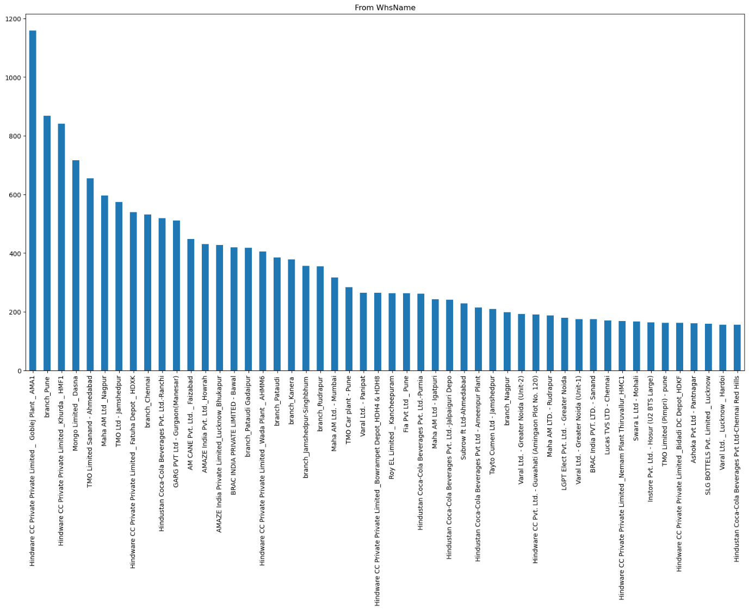

* 1939 To warehouses are there
* Top 50 To ware are shown.

**Model Type column:**

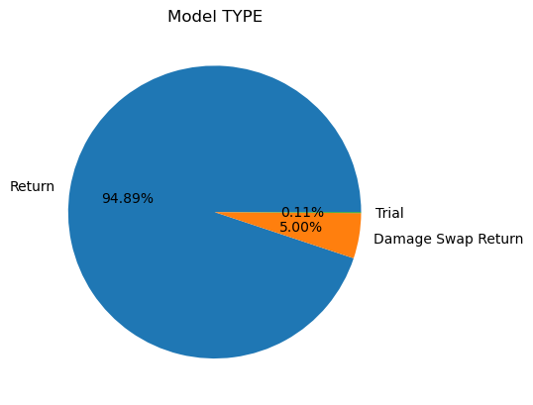

* Three model types Dehire, return swamp and trial.
* Dehire – return is 94.89% damage swap is very less of 5.0%, trail is 0.005%.

**Transfer Type column:**

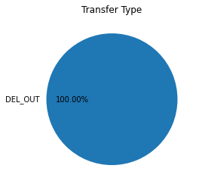

* Delivery out happened all the times.
* There is no such variation in transfer type.

**U_Frt column:**

* Avg U_Frt: 1537.7

**U_ActShipType column:**

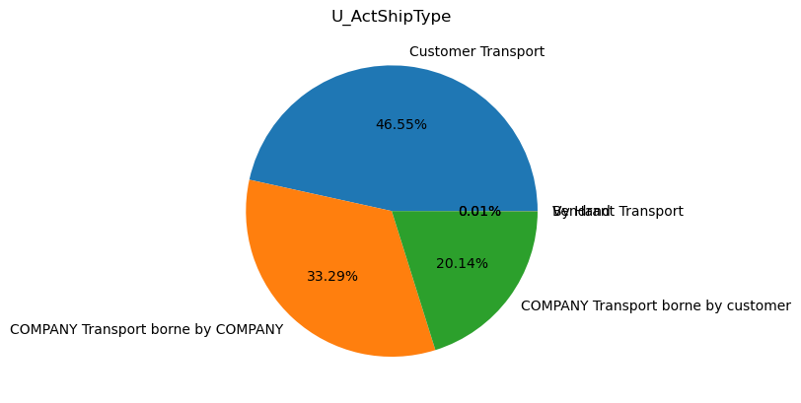

* There are 3 U_ActShipType.
* Company Transport borne by company is more followed by company transport borne by customer, customer transport.
* Other two are very few.

**Product category column:**

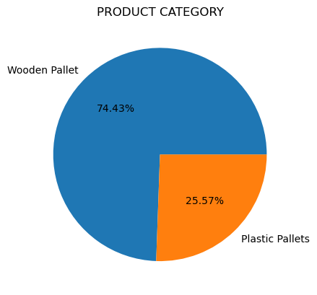

* There are 2 product categories wooden and plastic pallets.
* Wooden Pallets are more manufactured 74.43% and plastic pallets are 25.57%.

**Item Code column:**

* 43 unique items are present.

**NUMBER OF ORDERS PLACED column:**

* On an average 127 orders are placed by a customer.

**DESCRIPTION**

* There are 42 Descriptions of products.
* All Descriptions are shown.
* There size of pallets most oftenly manufactured.

WP 1210 1200 x 1000 x 157 PL Pallet SW 0.334095

WP 1200 x 1000 E Pallet SW 0.260486

SFLC PP 1200 X 800

**Quantity column:**

Average Quantity received by the customer **-122.28**

The quantities is in negative values so it is again multiplied by -1

**Unit column:**

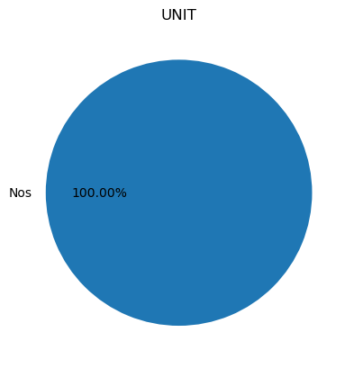

* Unit is given by nos. and it represents the number of quantities.

**Rate column:**

* Avg. rate is 2026.9

**U_Docstatus column:**

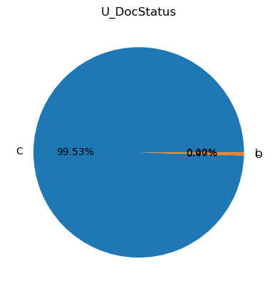

* C and O are two document status
* C happened most of the times and there is no such variation in this column.

**Document Type column:**

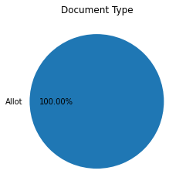

* Allot is the only document.

**Transporter Name:**

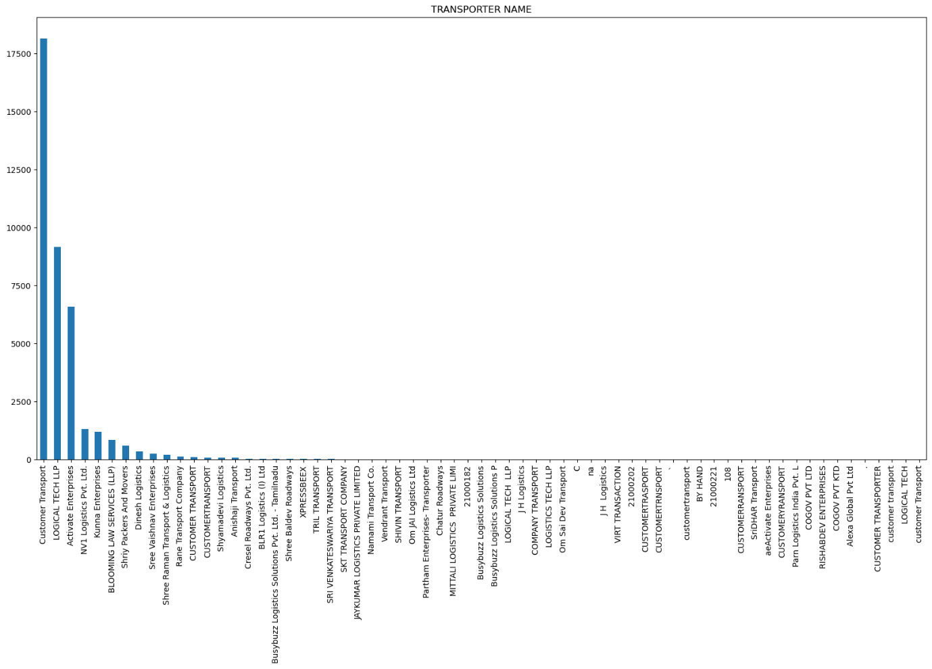

* 53 transporters are there

**Major transport**

Major transport

Customer Transport 0.460404

LOGICAL TECH LLP 0.232219

Activate Enterprises 0.167035

**BP_category column:** 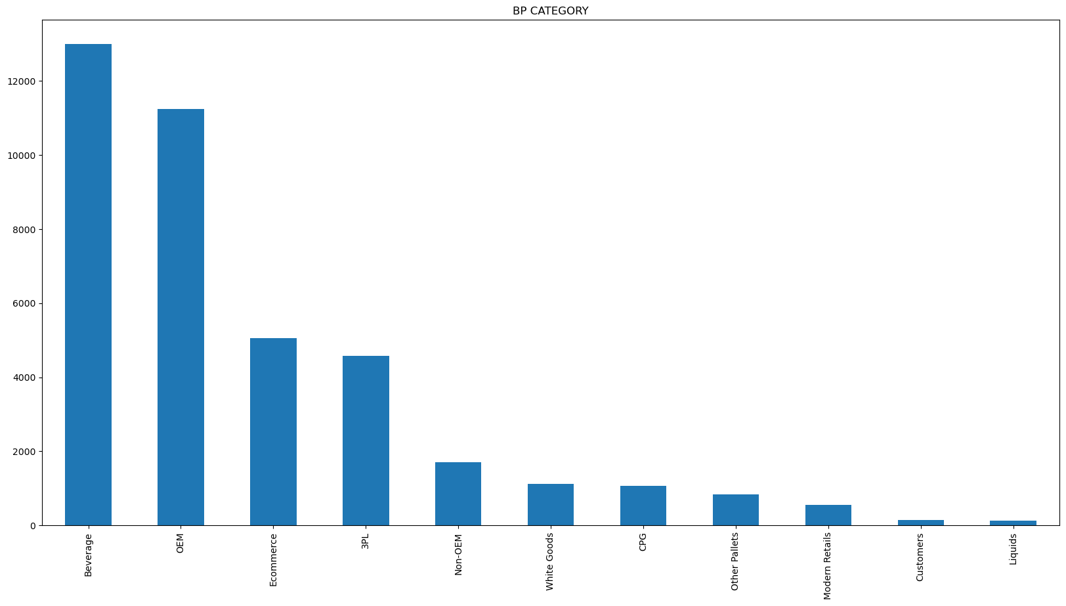

**Major Bp categories are**

Beverage 0.329883

OEM 0.285200

Ecommerce 0.128061

3PL 0.116084

**U_so type column:**

* Rent is the most happened and the rest is near zero.

**Vehicle Type column:**

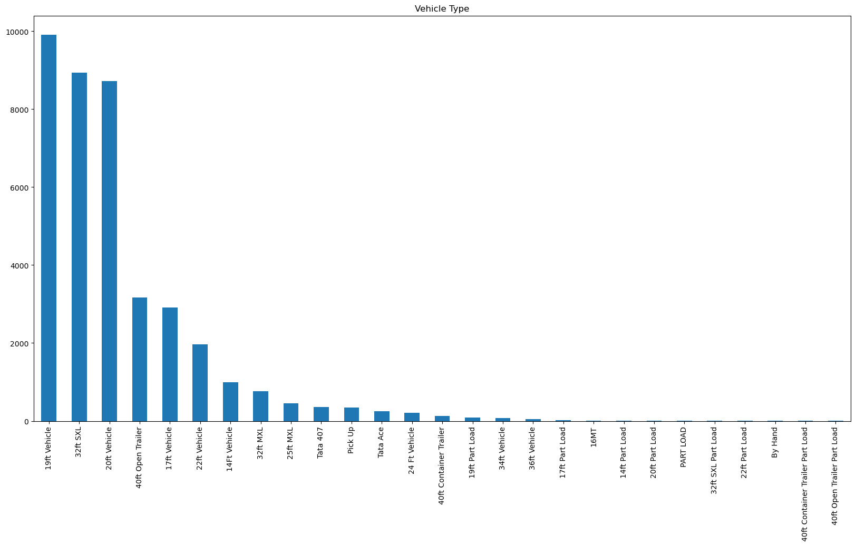

* 27 unique vehicles are there

**Major vehicles**

* 19ft Vehicle 0.258297
* 20ft Vehicle 0.249472
* 32ft SXL 0.159944
* 17ft Vehicle 0.116385
* 40ft Open Trailer 0.058433

**Direct dispatch column:**

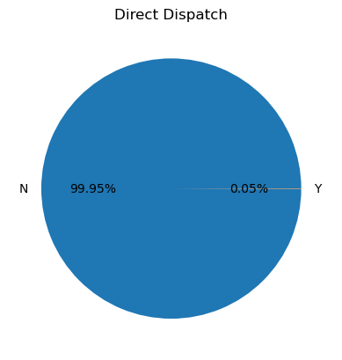

* N happened most of the time.
* Y happened to be the least.

**Loading/unloading column:** 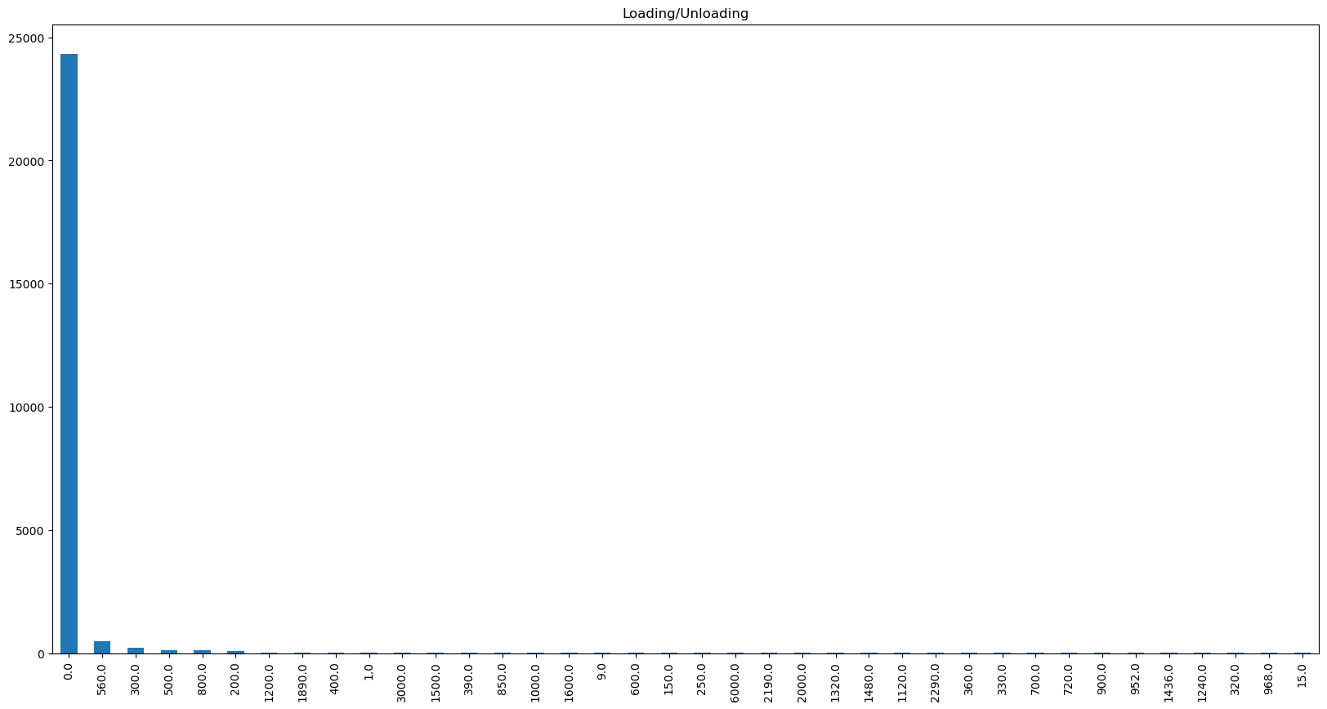

* loading/unloading doesn't happen most of the times.

**Detention**

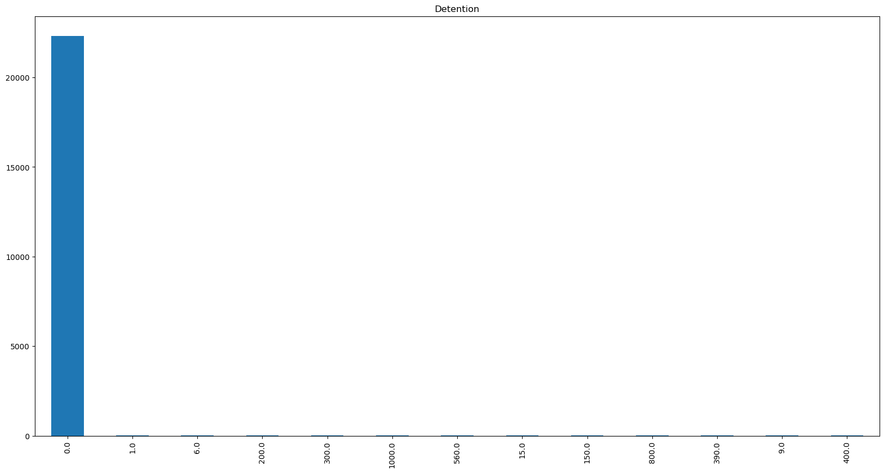

**Business head column:**

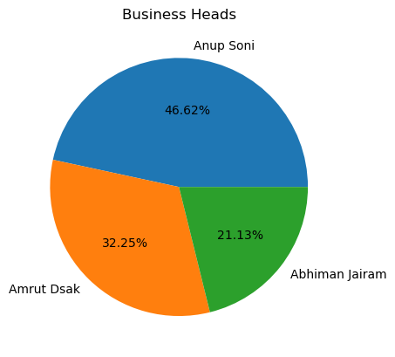

* Total 3 business heads.

U_AssetClass

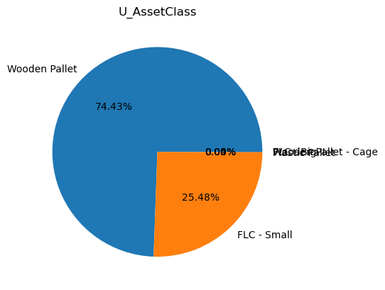

Wooden Pallet 0.744291

FLC - Small 0.254821

Plastic Pallet 0.000457

FLC - Big 0.000381

Wooden Pallet - Cage 0.000025

**Customer Type column:**

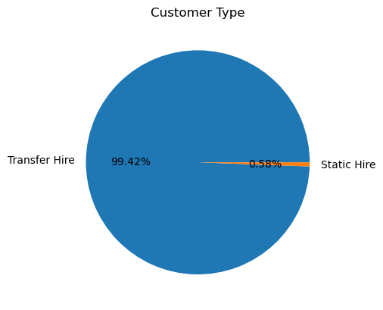

* Two types of customers.
* Transfer hire is the majority followed by static hire

**Flow Name**

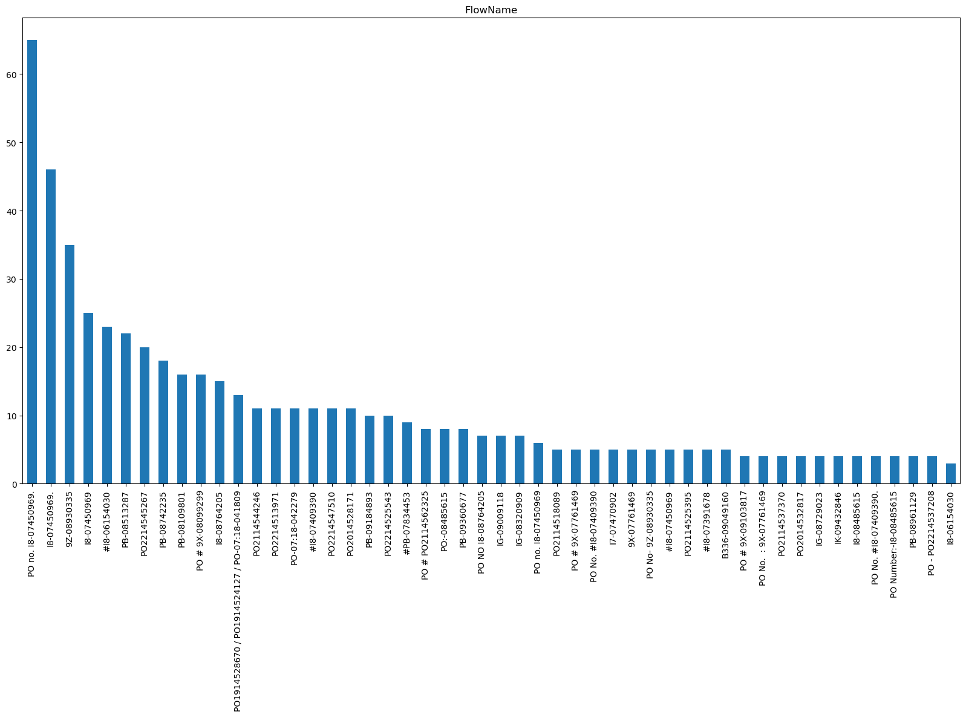

* There are unique flow names 1926